Accessibility report
An audit of the accessibility of the area of Notre-Dame-de-Grâce
SUMMER 2018
lES HABITATIONS ADAPTÉES ET ACCESSIBLES TANGO
4235 Ave. Prince-of-Wales, Notre-Dame-de-Grâce
Introduction

This report has been commissioned by Les Habitations Accessibles et Adaptées Tango (Tango), a non-profit organization. Tango is an accessible residence for individual with disabilities in the city of Notre-Dame-de-Grâce (NDG). This report aims to further an understanding of universal accessibility, to advocate and make suggestions for better accessibility in the city of NDG and to act as a guide for future resources within the city.

The present report is a result of an audit of municipal facilities and businesses conducted in NDG. The audit was conducted with the location of Tango in mind; it targeted areas of interest to the tenants, as well as busy streets. Below is a map of NDG, with the audited streets highlighted. Also audited were Benny Park, as well as the NDG Sports Centre.

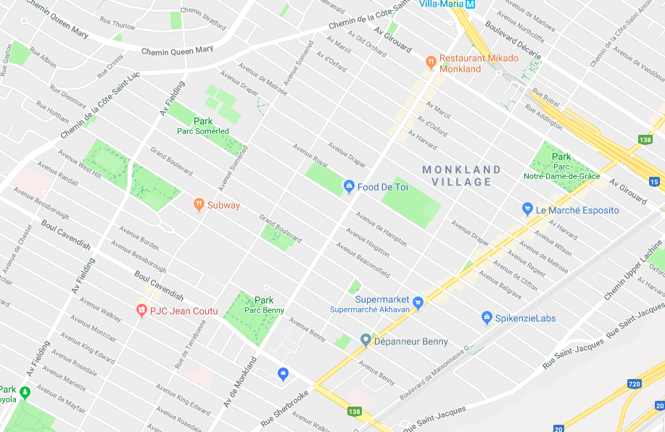

The audit constituted of two main parts- the inside of businesses and municipal facilities were considered, as were the intersections and roads outside. Establishments were evaluated based on various components, ranging from whether there were automatic doors to the accessibility of the bathroom. The evaluation metrics for the audit were created based on input from Tango residents and the concept of universal accessibility. The metrics were compiled into an easy-to-use checklist (See Appendix 1).

The streets and intersections were evaluated based on their smoothness, the size and cut of the curb and how well-lit they were. Also evaluated were the visibility of the street signs and the use of Braille and audible signals for those with visual impairments (See Appendix 2).
Defining Universal Accessibility

Throughout this report, the term “universal accessibility” is often used. It therefore deserves to be defined and understood independently. Universal accessibility refers to the idea that all spaces, public and private, should be inherently easy to access, easy to use and enjoyable for all individuals, regardless of ability, race, gender, etc. Universal accessibility requires that spaces are designed with this concept in mind, rather than as an afterthought.

Tied to the concept of Universal Accessibility is the concept of Universal Design (UD). According to the North Carolina State University, UD is defined by a set of seven principles:

- Equitable Use
- Flexibility in Use
- Simple and Intuitive Use
- Perceptible Information
- Tolerance for Error
- Low Physical Effort
- Size and Space for Approach and Use

These seven principles ensure that individuals are not discriminated against and are able to easily use and access spaces as they choose. In businesses such as restaurants and stores, accessibility can be embraced by simple measures, such as easily to maneuver ramps as well as more complex measures such as designing a Braille emergency exit plan. Universal design removes unnecessary complexity and aims not for equality in use but equity.

Universal accessibility and design are crucial to building a more inclusive and equitable society. However, these concepts cannot only be applied to certain spaces- they must be systematically and automatically applied to all public spaces. Another important component of Universal Accessibility is collaboration and dialogue. A space cannot be universally accessible and designed as such without a dialogue between the creators of the space and its users. Open and inclusive dialogue is vital, as it ensures that all voices are heard, especially those that are typically marginalized.

Throughout this report, it is vital to remember that ‘disability’ has many different definitions and encompasses a variety of conditions, from visual impairment to cerebral palsy. It is therefore important to consider that different individuals have different needs and wants. There is no one definition of disability; this report has attempted to be as inclusive as possible, however, there is always room for more inclusivity.

Audit Results: Municipal Facilities

Benny Library

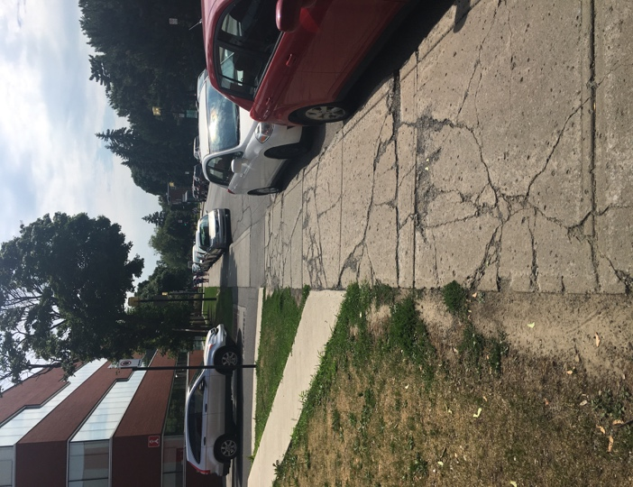
The first municipal facility audited was the Benny Library, located on Monkland Avenue. As a public building, a library needs to be universally accessible for all and its staff needs to be sensitized to accessibility needs. The library is easy to see and is located in a central location, making it accessible to people without private vehicles. However, the sidewalk outside the library is full of cracks and therefore difficult to navigate. As can be seen in the picture below, the sidewalk is dangerous and inhibits access to a public facility.

The doors of the library are automatic and are wide enough for a wheelchair or wide walker to fit through. The entry itself does not require a ramp, as it is flat and smooth. What is inaccessible, especially for people of short stature or in a wheelchair, is the book deposit slot. The slot is high up on the outside wall of the library and requires that a person be able to easily reach the slot to easily use it. Furthermore, the magazine rack just inside the doors of the library is also too high to reach from a wheelchair or a low height.

Once inside the library, the space is air conditioned and well lit, with smooth floors that are easy to walk on and easy to use for wheelchairs. On the left of the entrance is a sitting area with couches and tables. The couches are of appropriate height and can easily be used. The tables and chairs, on the other hand, are very high and difficult to sit on.

The inside of the library, where the books and bookshelves are located, is uncluttered and easy to maneuver in a wheelchair and with a walker. The rows are marked with easy to read text, but not in Braille. The books shelves are well arranged, and books are easy to find for sighted individuals, though many books are too high to reach from a wheelchair. Furthermore, though there are multiple computers to search for books and to check books out, they are placed on very high tables that are very difficult to reach. Below is a photograph demonstrating the problematic height of the computer tables. In addition to this, the computers are very difficult to use for people who have impaired vision. Because the computers are so high and difficult to utilize, people have no choice but to ask the librarians for help, which may make some people feel that they are being a burden and too dependent.

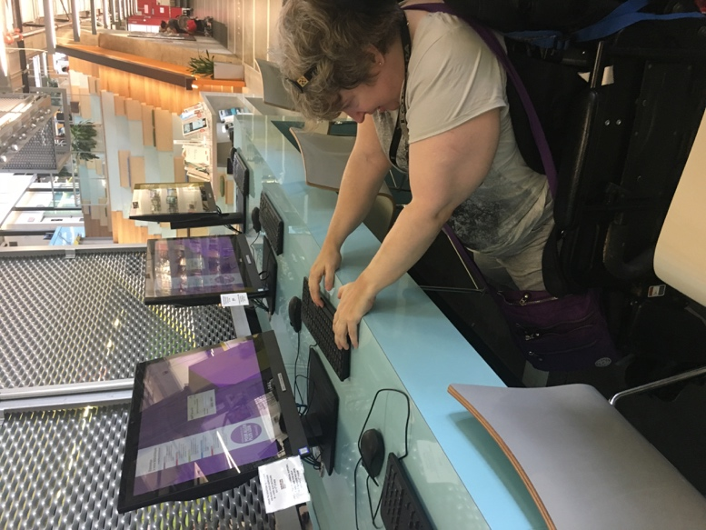
It was also noted that the library has no signs, in English French or in Braille, that encourage patrons to ask for assistance if needed. Signs such as these can reassure those who may need assistance that their questions and needs are valid.

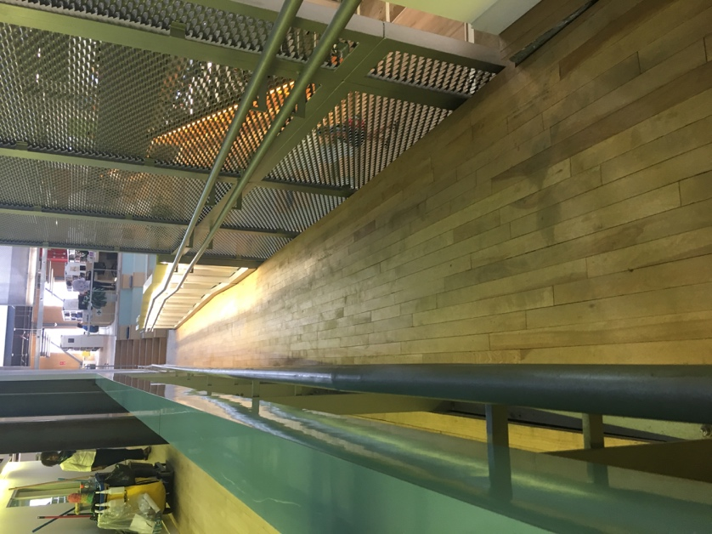
The children’s section of the library is accessible for children and their parents. The children’s bathrooms are designed to accommodate children, that is, they are built at a smaller scale with a lower toilet, sink, soap and paper dispenser. These measures allow children to be more independent and easily use the facilities. Next to the children’s bathroom, there is a nursing room. The nursing room is quite small with not enough space for a wheelchair to turn around in. The sink in the room is too high for someone in a wheelchair to use and there are no bars in the room for support However, the room well-lit and has a door with an easily graspable handle.

To reach the upper level of the library, there is an elevator, which has buttons in Braille and has audible signals that announce the direction and floor number. The elevator is easy to operate, and the buttons can be pressed from a wheelchair with ease. The second floor is similar in design to the first in that the rows are easily maneuverable but have no Braille signs. Furthermore, the top of the shelves is difficult to reach from a wheelchair or at a low height. Similar to the first floor, the computers and desks are too high to reach. There is, however, a single computer with a desk that is low enough to reach but it is too narrow for someone in a wheelchair to comfortably use the computer.

There is also a ramp on the second floor which seems to lead to another level, however, it does not lead anywhere, other than the top of an auditorium-style sitting area. This is dangerous, as it can mislead wheelchair users who wish to use the ramp to go downstairs. If they do follow the ramp down, they are stuck at the top of the steps with a very narrow space to turn around in. Not only is this dangerous for wheelchair users, but also for young children and other people with limited mobility. It is strongly suggested that this ramp be cordoned off with a sign that advises people where the ramp leads. This can prevent accidents and people getting stuck.

Another issue on the second floor is the washrooms. There are three washrooms, for men, women and people in wheelchairs. The men and women’s bathrooms are inaccessible, as the stalls are too small for a wheelchair to fit in. The bathroom for people with disabilities is much larger and well-lit, however, the toilet and toilet paper dispenser are much too low to use comfortably, even with grab bars on the side of the toilet. The toilet in this bathroom is the same height as the toilet in the children’s bathroom. Whether this was an oversight, or a conscious design judgement is unclear. Additionally, though the sink is easy to reach for individuals in a wheelchair, the soap dispenser and the paper towel dispenser are too high to use.

There is a way from besides the bookshelves to reach where the documentaries and research documents are stored, however, the floor is somewhat uneven, making it difficult for people with walkers, manual wheelchairs or balance issues to navigate. The reading tables in this section are of appropriate height, however, the computers are still unusable.

One jarring inaccessibility is the lack of Braille books and audiobooks at the library. When asked, a librarian mentioned that Braille books and audio books can be ordered from other libraries. While this is helpful, it inhibits as others. This also requires that people know that they wish to listen to or read in Braille, which requires preplanning and knowledge of what is actually available. These are not typically things that people who read non-Braille books have to find out before going to the library and should therefore not be required of people who have impaired vision.

CLSC Benny Farm

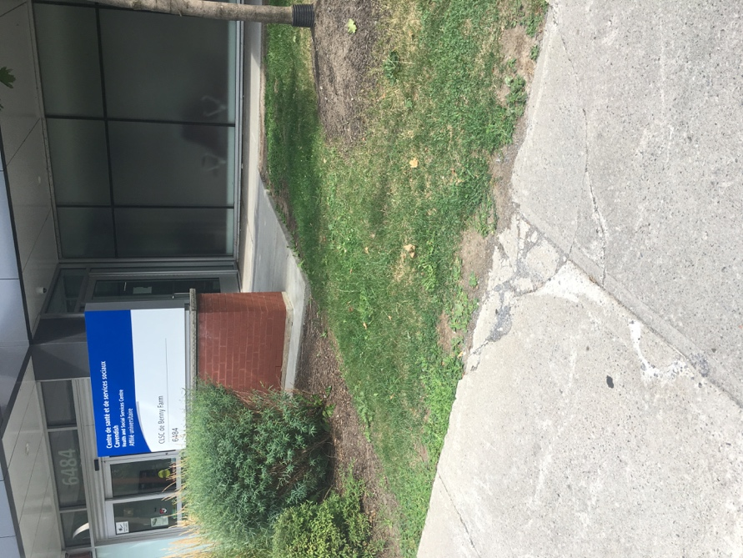
The side walk and intersection leading to the Benny Farm CLSC are difficult to navigate as they are cracked and uneven. The adjoining picture shows one large crack in the sidewalk right outside the CLSC. Though this crack is in the corner, it still restricts movements and narrows the sidewalk.

The CLSC has a parking lot, with a parking space near the door for people with disabilities. There is also a ramp that leads from the parking lot to the door of the CLSC. What can be improved, however, are the height of the electric car charger and the parking meter, which are too high to access from a wheelchair.

The front entry of the CLSC, which is on Monkland is accessible, as it has a flat entryway and automatic doors; the doors are clearly marked with an accessibility sign. The inside of the CLSC is well-lit and air conditioned, with enough space to maneuver.

Inside the CLSC, the ticket machine is touch screen, with large letters. This can be difficult to use for people with visual impairments, as the screen is completely flat and has no Braille lettering. Furthermore, the machine gives no audible signals and prints tickets that cannot be read by people with visual impairments. Once the ticket is printed, the ticket number appears on screens around the waiting area. While efficient, this system is once again difficult to use as there are no auditory signals indicating the ticket number or the counter number. Though staff can help people who cannot read the screens and use the ticket machine, it is important that people are able to independently access the services of the CLSC.

It was also noted that the counters of the CLSC are very high and difficult to see over for people at a low height and people in wheelchairs. There is a similar problem with the telephones in the lobby and the water fountains. Both are very high and cannot be reached from a seated position.

There are elevators available at the CLSC, which are wide enough for a wheelchair to turn around in. The elevator buttons are marked in Braille and have raised numbers and there are audible signals that indicate the floor number.

The bathrooms are accessible and there are clear visual signs indicating where the bathroom is. There are, however, no braille signs to indicate where the bathroom is nor are their Braille signs distinguishing which bathroom is which. Inside the bathroom, wheelchair to turn and bar on one side of the toilet. While the paper towel dispenser is easy to reach, the soap dispenser is not, which is a common issue in many public bathrooms. What is worth noting is that there are changing stations in both bathrooms, which allows parents to attend to their children regardless of which bathroom they are in. The changing table is low enough for wheelchair users and is large enough for a child and other equipment. Similarly, the nursing room is accessible, with a large space and low chair, but is difficult to find as the signs are small and difficult to see.

Notre-Dame-de-Grâce Sports Centre

The most important aspect of the Sports Centre, for the Tango tenants, is the indoor pool. The pool has free swim the afternoons and in the evenings on most days, which allows for easy access. The Sports Centre can be accessed through the Benny Park and has a long incline at the front entrance, which makes it accessible for manual wheelchairs and walkers. The ramp is quite wide and clear of obstruction. The entrance is easy to find, and the doors of the building are automatic and wide enough for a wheelchair or a walker. The inside lobby of the Centre is well-lit and air-conditioned and largely uncluttered.

What is concerning however, is the height of the counter of the service desk. The counter is extremely high, making it difficult to access for wheelchair users, children and people of short stature. Though the staff is accommodating, the counter creates an artificial barrier and stops people from asking questions.

Another concern is the narrow turnstile and corridor leading to the changing rooms. The corridor is only large enough to accommodate one wheelchair and requires that everyone else move out of the way. A wheelchair user cannot turn around easily, which poses a hazard in the case of an emergency evacuation or any other issue.

The changing rooms are largely accessible, as there is enough space for a wheelchair or walker to maneuver through to reach the pool deck. What can be improved is the lighting in the changing rooms, as they are not well lit and can pose problems for people with low visibility. The women’s and family changing rooms have seats and facilities for children which are not too high and intuitive to use. Unfortunately, these facilities are lacking in the men’s changing room. The argument can be made that men with young children can and should use the family changing room, however, this should be the same for women with young children. There is therefore no reason not to have changing facilities and children’s seating in both changing rooms. There is also a need for Braille signs leading to the changing rooms and Braille signs distinguishing the changing rooms.

The pool deck itself is easy to reach and is largely dry. The smaller pool can be accessed with a ramp, which gradually descends into the water. There is a rail on the ramp which makes walking down the ramp easier for individuals who may have trouble walking. The larger pool does not have a ramp, but instead has steps with a rail to guide people into the pool. The larger pool also has three lanes, for slow swimmers, average swimmers and fast swimmers. This makes the pool easier to use for those who may be learning to swim or may have difficulty swimming and for those who wish to swim undisturbed.

The lifeguards at the pool are accommodating and helpful, however, there is a concern that they are not trained in first-aid techniques specifically for people with disabilities. The typical first aid training course and lifeguard course does not cover emergency aid techniques for wheel-chair users or people who require specific care. This training is especially important as it can assure individuals with disabilities that they will be well taken care of in emergency situations. This assurance is important as it helps individuals feel safer at the Sports Centre and encourages them to use the various facilities at the Centre.

Above the pool, there is a café and observation deck both of which can be accessed by an elevator. The elevator is located in the lobby of the Sports Centre and is large enough for a wheelchair to turn. The elevator has easy to reach buttons with raised numbers. The elevator also gives audible signals to indicate the floor. The café is accessible, with easy to use tables and chairs. The counter of the café is at a low height and there are menu cards that customers can take. What can be improved is the introduction of a Braille menu card, which would allow people with visual impairments to independently read the menu and decide what to order.

Overall, the Sport Centre is largely accessible and requires few adjustments. What could improve the accessibility of the pool are courses specially designed for people with disabilities so that they could learn to swim or take water-based fitness classes. Furthermore, it could be beneficial to have a special free-swimming time for individuals with disabilities.

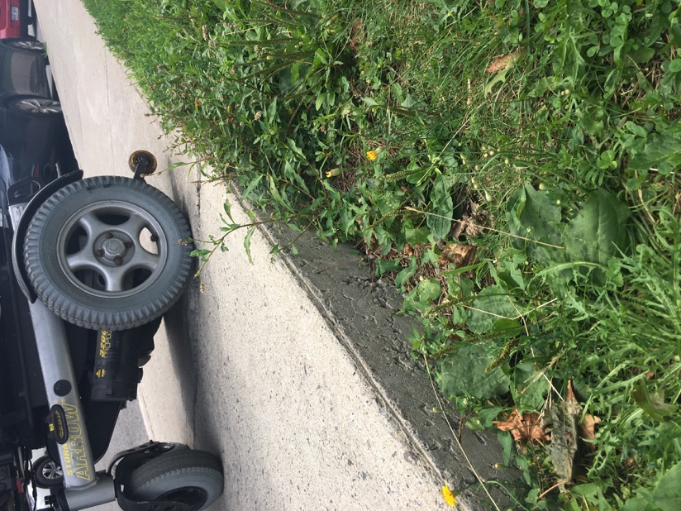
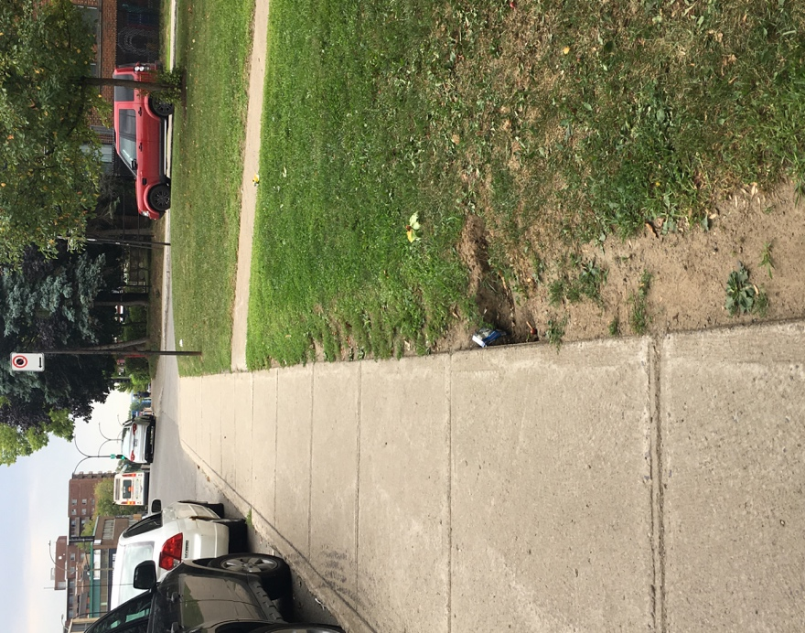
Monkland Intersections

The largest accessibility issue in NDG are the intersections and the condition of the roads and sidewalks. Due to regular wear and tear and improper design, the roads can be quite dangerous for everyone. The most common problem encountered with the intersections on Monkland, between Cavendish and Girouard, are narrow curbs, cracks in the sidewalk and damaged curb cuts.

Furthermore, there are holes between the sidewalk and the grass next to it, which are very dangerous. As can be seen in the above pictures, there is a gap between in the sidewalk and the grass which is large enough for a wheel to get stuck in.

A large concern are the intersections, which are often busy. The four-way intersection of Cavendish and Sherbrooke, specifically, is very busy and difficult to navigate. Though there are traffic lights, there are no audible signals that indicate when it is safe to walk across. For people with visual impairments, it is essential that they know when it is safe to walk, as they cannot see vehicles coming towards them, nor can judge how far and fast a vehicle is coming. Audible signals such as beeps or spoken directions are essential for all intersections as they help individuals with visual impairments cross the roads by themselves and maintain a degree of independence.

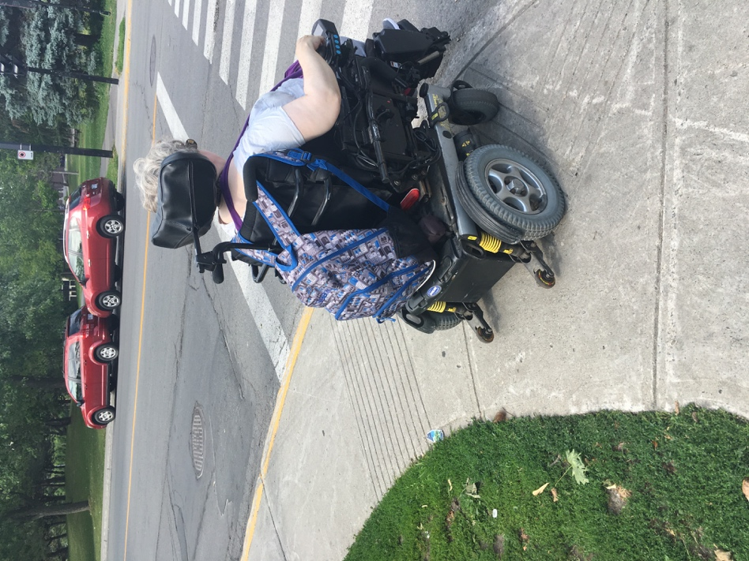
Another common problem is the narrowness of the curbs and the curb cuts. As can be seen in the picture, a compact electric wheelchair takes up nearly the whole curb. The user cannot turn the chair easily; do to so would require careful maneuvering to ensure that the wheelchair does not hit others and does not end up on the road.

The other issue the size and quality of the curb cuts. These cuts allow users to make a smooth transition from the sidewalk to the road. However, these cuts are often too small to use and are damaged, making them bumpy and difficult to roll or walk onto. This also makes the transition from the sidewalk to the road or vice versa dangerous, as a wheelchair can get stuck or tip over. These cuts are also dangerous for other people as they are easy to trip over. In addition to this, the road adjacent to the curb is often filled with water when it rains or after it rains. Puddles by the curb not only erode the road but can lead to misjudgment of who steep the curb is and how far the road is. Puddles inconvenience all pedestrians and can be a hazard for walkers, strollers and bicycles.

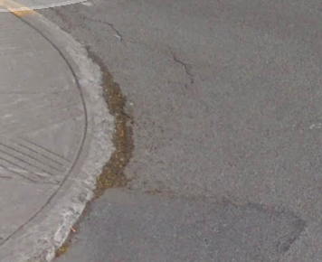
A further issue that needs to be addressed, is the condition of the roads themselves. Due to seasonal wear and tear and the roads have become cracked and can be dangerous to the flow of traffic and for people crossing the street. As can be seen in the first picture on the next page, there is a hole in the middle of the intersection of Cavendish and Monkland. This hole is large enough for a wheelchair tire or walker to get stuck in, which is extremely dangerous. The second picture shows a road that has been repaired, however, this repair work was not done well, as thus the road remains uneven and still dangerous to all pedestrians.

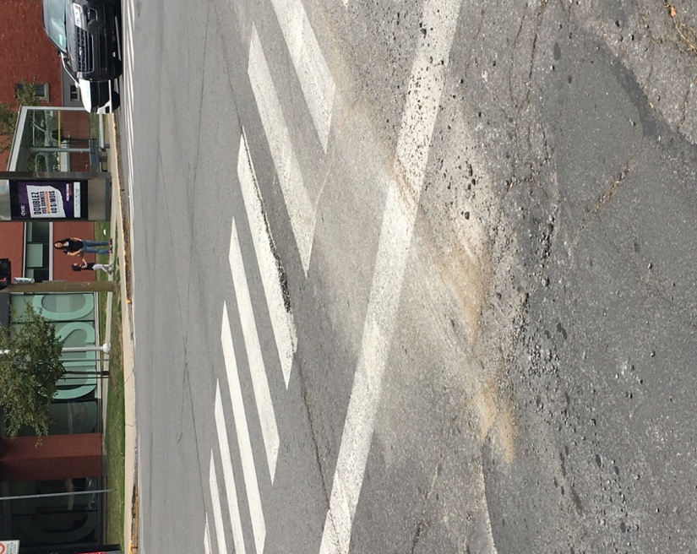
The overall unevenness of the roads is also a problem for people who are crossing. At such a busy intersection, people cannot cross the road quickly and efficiently, as the road is cracked, uneven and generally unsafe. This is further complicated by the short crossing time, typically about 20 seconds, which can lead to people preferring to remain home rather than risk being hurt or incapacitated.

Smaller intersections along Monkland have similar problems and other problems, such as the lack of traffic signals or auditory signals indicating when it is safe to cross. Another problem that was noticed was the lack of proper painted crosswalks. These cross walks are crucial, as they demarcate where vehicles must stop and where pedestrians can cross. The curb cuts on these intersections are also quite narrow and require manual wheelchair users to either wait on the road to cross or have someone accompany them. Though these intersections are smaller and not as busy, they can still be dangerous for all pedestrians, with or without disabilities.

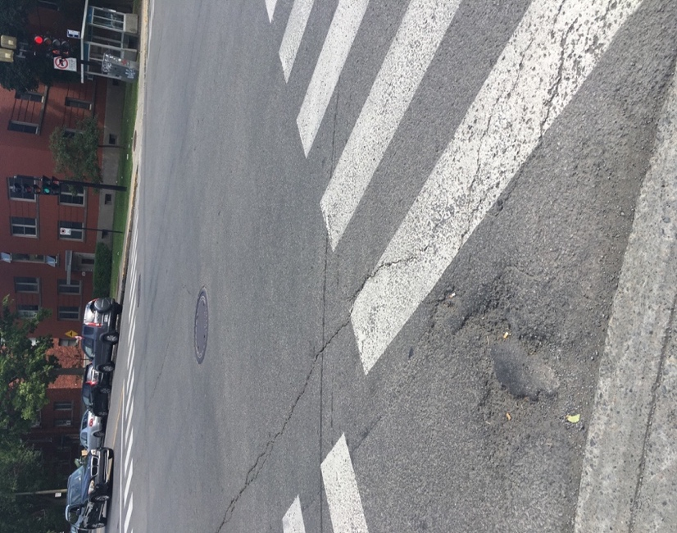
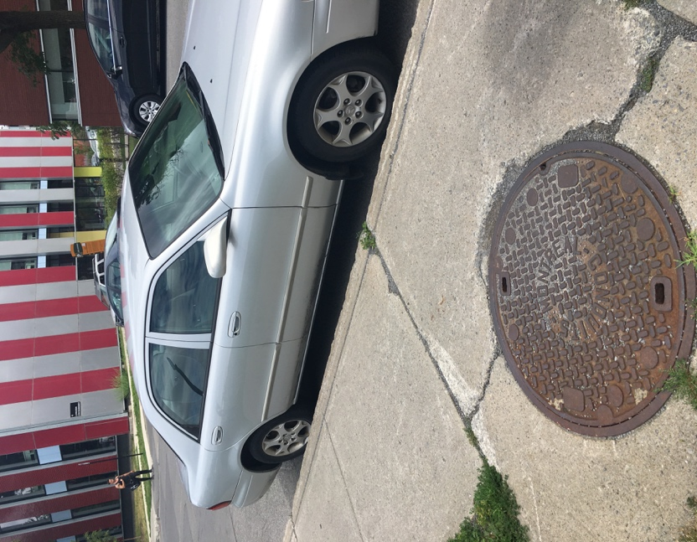

Sherbrooke West Intersections

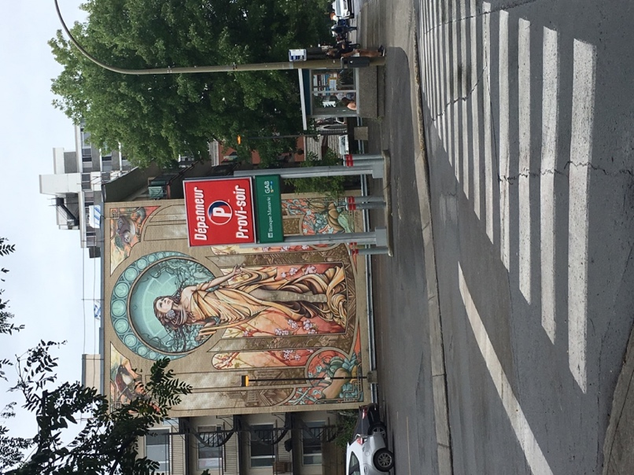
As abovementioned, the audit was carried out on Sherbrooke Street from the intersection of Cavendish to Girouard. Similar to the streets of Monkland, the roads and sidewalks of Sherbrooke West tend to be cracked and uneven. Being a busy street, with many restaurants and businesses, Sherbrooke West needs to be well-designed and well-maintained. Undoubtedly, the sidewalks are wide, and the street is well lit, making it accessible during the day and the night. However, there are often cracks in the sidewalks and the road, making them difficult to traverse. As can be seen in the picture on the next page, the intersection, despite being easy to see, is cracked and uneven. Furthermore, there are no visual or auditory signals that indicate when it is safe to cross.

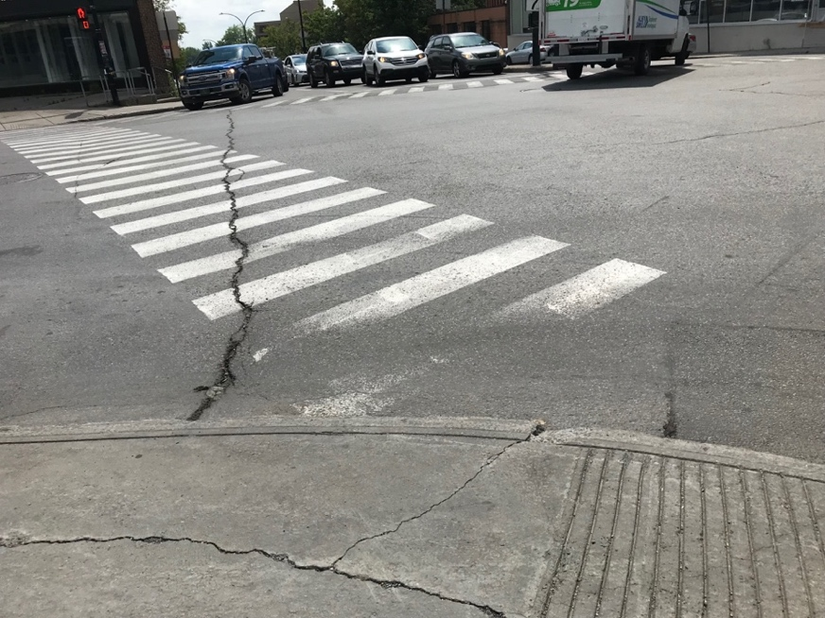
There are many small intersections like this on Sherbrooke West. It is therefore difficult for people to cross and to feel safe alone on the streets. Though many people do have others accompanying them, it is essential that they be able to use the roads and sidewalks independently and safely if they choose to do so.

For the residents of Tango, the most challenging intersection on Sherbrooke to navigate safely is the intersection of Sherbrooke and Cavendish. This intersection is frequently traversed by residents, as it leads to a grocery store, Provigo, and a pharmacy, Pharmaprix. This intersection is extremely busy, with vehicles traveling at high speeds and heavy pedestrian traffic. Though there is an audible signal to indicate when it safe to walk, it cannot be heard over the noise of traffic. Furthermore, it is difficult to decipher what the fast beeping means; does it mean it is safe to cross or does it mean it is unsafe to cross? There are also buttons on the traffic lights, which presumably are for pedestrians to indicate that they wish to cross. These buttons are usually ignored, as they take too long to work and are difficult to see from afar.

The crosswalks on this intersection are lengthy and need to be crossed quickly due to the short signal time, which is not always possible for everyone. To complicate the matter, the roads are cracked and uneven and traffic is very impatient. While crossing the road, Tango residents experienced nervousness and anxiety, as they felt very unsafe and vulnerable. Residents also reported that they would often be honked at as they tried to cross, as vehicles would attempt to turn quickly.

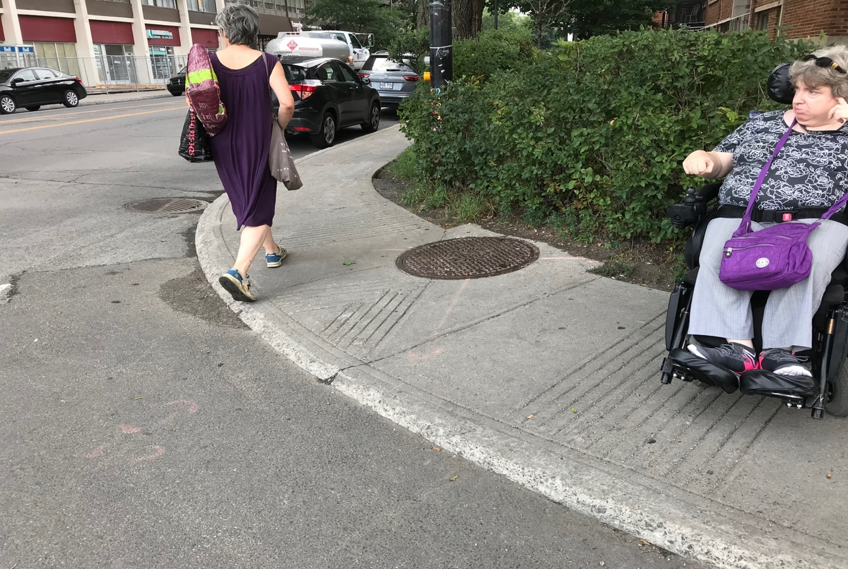
Another reported issue was the narrowness of the curbs and the small curb cuts. In the photograph below, it can be seen that wheelchairs or walkers cannot stand too close to the curb cut as it blocks other pedestrians from using the cut. Additionally, the curb cuts are so narrow that they require careful maneuvering. As seen below, the curb cut cannot be used by the automatic wheelchair user to wait for the signal to change, as there is not enough space for other pedestrians. Even with the sidewalk becoming wider where the cut is, due to the pothole cover, the automatic wheelchair user must wait on the side and then maneuver onto the curb cut, then onto the road and across the street. All this must be done within the time it takes for the signal to change from green to red, about 22 seconds at this intersection. This problem is graver for walkers and manual wheelchairs, which are wider and more difficult to maneuver.

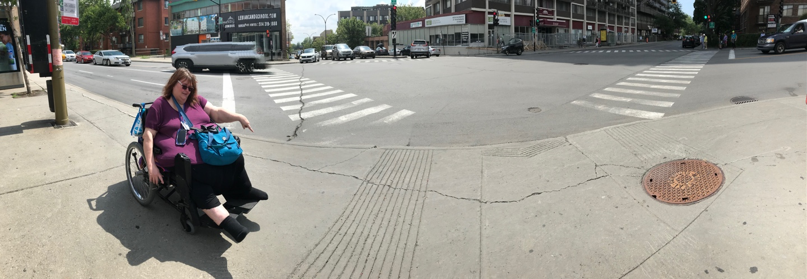

Similar to the issue faced with the intersections, it was noted that the sidewalks on Sherbrooke, from Cavendish to Girouard were also damaged and potentially dangerous. These cracks can cause damage to a wheelchair or walker and can potentially lead to injury. It was noted that there was little effort to fix these cracks in the sidewalk, despite their severity.

Somerled Intersections
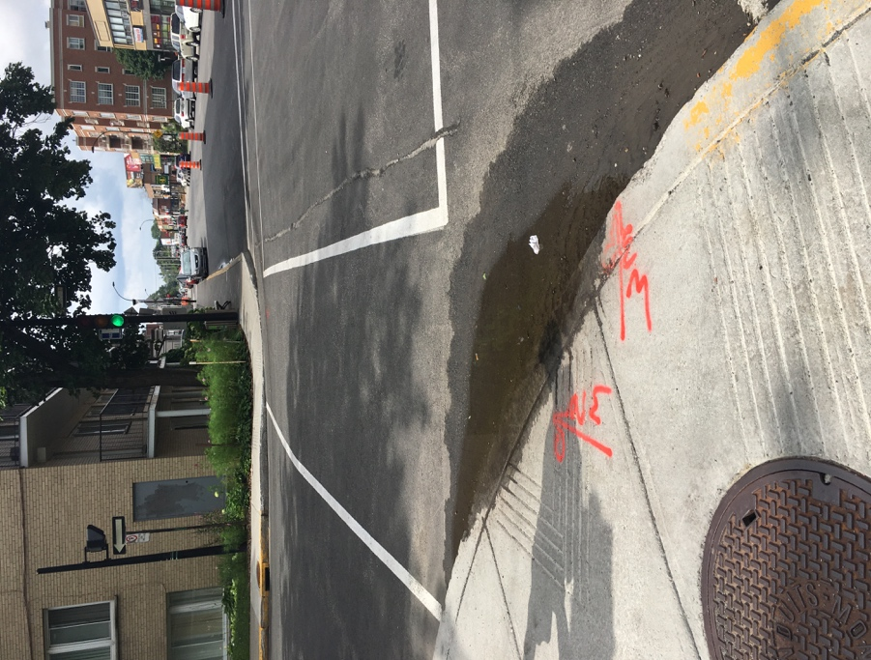
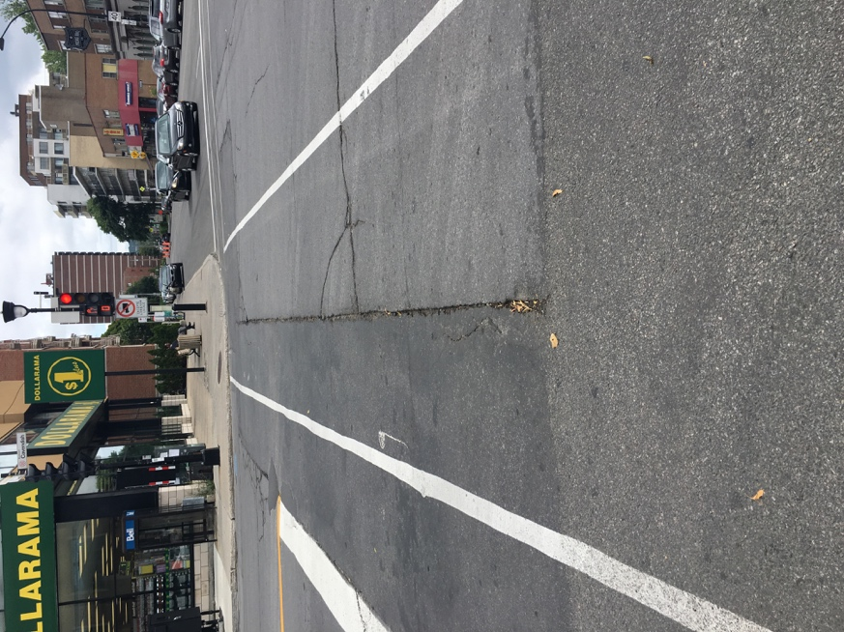

The intersections and streets of Somerled have issues similar to the ones mentioned above. What is notable about Somerled is that many of its intersections are not controlled by traffic signals; these intersections also have damaged curb cuts. This makes the street difficult to traverse and slows down pedestrian movement on the street. Furthermore, as seen in the picture, there are long cracks in many of the roads, making crossing difficult and anxiety inducing for many people. Though there are traffic signals, they change quickly and do not have auditory signals to indicate when it is safe to cross.

A matter that was brought up among the tenants of Tango was the need for Braille road signs. These signs need to be easy to reach and on each cross street to indicate the street name and direction. These signs are a crucial for people with visual impairments to maintain their independence and to be able to navigate the streets of NDG. Braille signs are very uncommon in the streets; they are usually reserved to the inside of public buildings and elevators. Adding Braille signs would greatly improve the accessibility of the street of NDG and would be a huge step to making NDG more inclusive.

Private Businesses

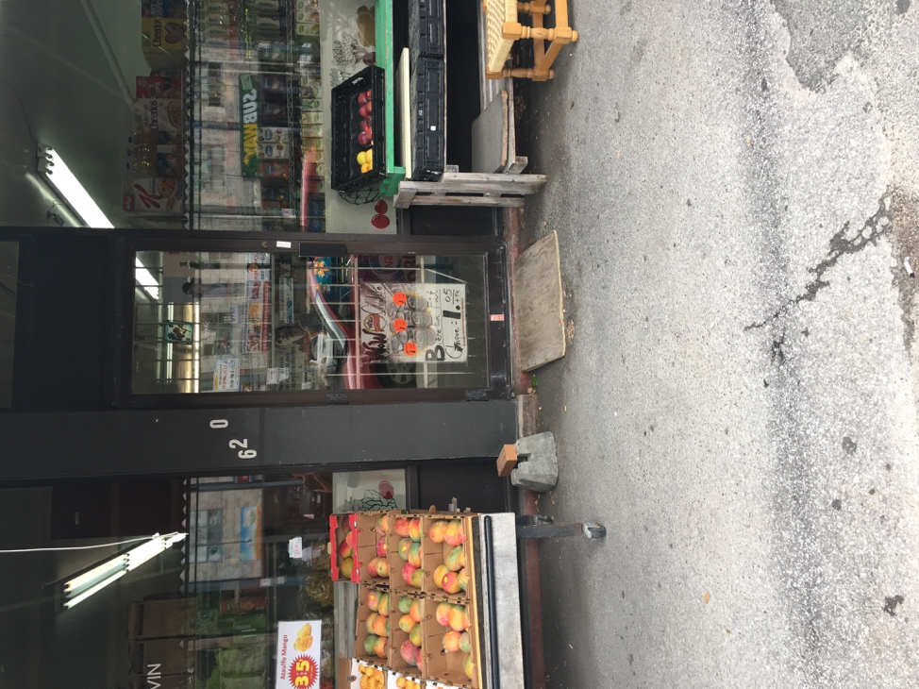
During the audit, businesses on Sherbrooke, Monkland and Somerled were audited and their accessibility evaluated. Businesses were evaluated on their accessibility inside and outside, as well as the sensitization of the staff to the needs of people with disabilities. Here, it is important to note that accessibility comes in many different forms and does not only include adding a ramp to a business.

It was found that many business owners were not aware of the concept of universal accessibility and had not really pondered over what accessibility means. Many business owners voiced a concern that making their stores or restaurants accessible would be very expensive and unaffordable. Many businesses that did have ramps also had not considered the fact that a ramp was not the only tool needed to make their business more accessible. For example, a cluttered corner store with a ramp outside is still inaccessible as it limits the mobility of wheelchair and walker users. In the picture, it can be seen that the business does have a ramp outside. However, the ramp is very small and unsteady, making it difficult to use. The entry way is also narrow, and the door cannot be opened automatically.

Generally, businesses that were cluttered or inaccessible offered to do business with the tenants outside, on the sidewalk. While this solution works in the summer, it becomes unfeasible in the winter. This solution is also not universally accessible, as it treats certain individuals differently and blatantly differentiates them from other consumers or clients.

It was noted that restaurants were generally more accessible than stores. Restaurants tended to have larger entrances, low tables and wait staff who could cater to different needs. Many restaurants also had accessible terraces, that could accommodate wheelchairs and walkers. Again, however, this solution is only viable for warm weather.

What was missing in every restaurant, were Braille menus. No restaurant visited during the audit had Braille menus, rather, they explained, the wait staff could describe the menu items to customers. Similarly, no store has Braille signs or labels for their products. Business owners reported that they had never encountered a visually impaired client or customer come in alone; they were typically accompanied by someone sighted. The thought that people visual impairments are always accompanied because businesses and streets are inaccessible did not occur to many business owners, until it was pointed out to them.

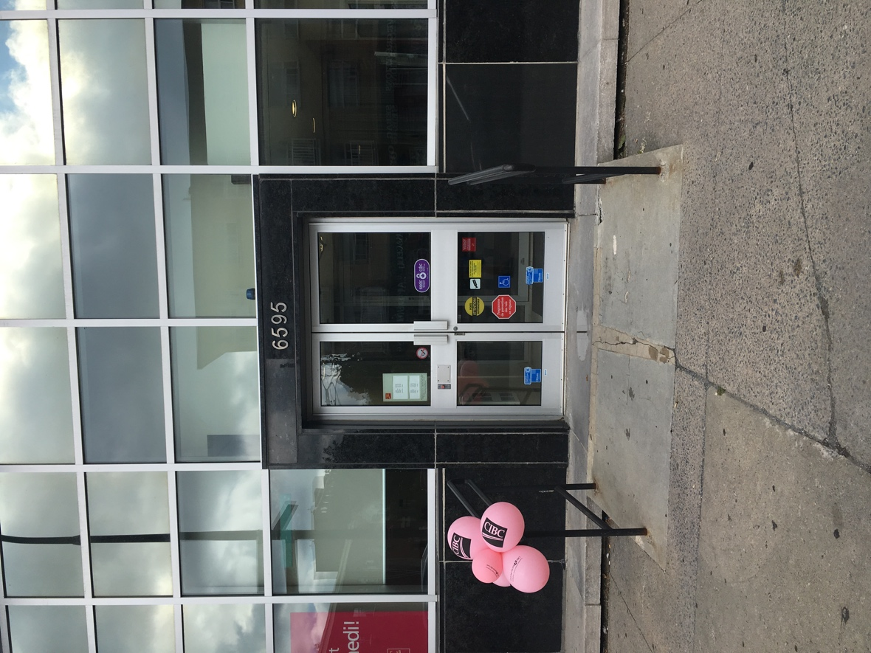
During the audit, it was also noted that institutions such as banks and pharmacies often described themselves as accessible, by putting an accessibility sign on their door, however, there were a few issues that were overlooked. One of the most commonly overlooked places were the bathrooms. Bathrooms were often large enough for a wheelchair to turn around or had a stall for people with disabilities. However, the ease of access often ended there. Missing were bars around the toilet, a low sink and paper towel dispenser and easy to open doors. Many of the bathrooms in these institutions had to be unlocked by employees and had heavy doors with door handles that were difficult to grip.

Another overlooked place was the parking lot. All buildings with a parking lot offered accessible parking spaces, demarcated with blue and white paint. Most parking lots had signs that also showed that accessible parking spots were available. However, these parking spaces did not have space on either side to accommodate a wheelchair or walker descending from a vehicle. Accessible parking spots were the same size as regular parking spots, and thus too narrow for wheelchair or walker users.

Recommendations

As investigated throughout the present report, there are many barriers to accessibility throughout the city of Notre-Dame-de-Grâce. These barriers are not only structural, but at are at times institutional and social. This section offers recommendations to address these barriers and to improve the neighborhood.

- Fix the roads, sidewalks and curbs of major streets, such as Monkland, Somerled, Cavendish and Sherbrooke in a quick and efficient manner
- Fix the roads, sidewalks and curbs of smaller streets in a quick and efficient manner
- Widen curbs to allow for a wheelchairs and walkers to easily turn and maneuver
- Fix holes on the edge of the sidewalk, to prevent wheels getting stuck
- Paint or repaint crosswalks so that they are easily visible during the day or at night
- Add audible signals to all crosswalks
- Add braille signs to street corners, at a reachable height
- Add bumps to each curb to indicate that end of the road and beginning of the sidewalk
- Remove all obstacles from sidewalks, such as bins and boxes
- Ensure that all municipal facilities are accessible inside and outside
- Sensitize municipality and city workers to accessibility needs and the concept of universal accessibility
- Work with private businesses to develop update accessibility regulations
- Engage community members to make the neighborhood more accessible and inclusive
- Work with people with various disabilities to find solutions and methods to apply the concept of universal accessibility
- Create a dialogue within the community to make the neighborhood more accessible and inclusive

Appendix 1: Checklist for Private Businesses/ Municipal Facilities

Entry

- Building is clearly marked with signs that show that it is accessible
- Building has a blue parking space near to the entrance
- There is space on either side of the parking spot for easy entry and exit with a ramp
- Ramp that leads from the street into the building
- Ramp is clear of obstruction
- Ramp is not too steep and easily maneuverable
- Ramp is non-slip
- Entrance is street level and easy to find
- The business has solid rails inside and outside to guide people
- Business is well lit
- Business is air conditioning/heated
- Doors are wide
- Doors can be opened with an automatic door opener
- Doors have easy grip lever handles
- Menus/information/labels are in large letters and in Braille
- The inside of the business is uncluttered and easy to maneuver
- Counters are at a low height
- The interact machine is low enough to access and is detachable
- Elevators are available and are wide enough for maneuverability
- Elevator buttons are marked in Braille and with raised numbers
- Elevators have audible signals that indicate the direction and floor number
- Elevators have easily seen visual signals that indicate the direction and floor number
- Business has a well thought out evacuation plan
- Fire alarms have both audio and visual signals
- Service animals are welcome

Bathrooms

- Bathroom is accessible
- Easily seen visual signs that point to the bathroom
- Braille signs that indicate where the bathroom is, and which bathroom is which
- The bathroom is big enough for a wheelchair to turn around
- Stalls are large enough for a wheelchair
- There are grab bars on both sides of the toilet
- The toilet is not too high
- The flush is easy to use
- The soap dispenser and paper towels/dryers are reachable at wheelchair height
- Floors are dry and not slippery
- No strong scents in the bathroom (ex. Bleach)

Staff

- Staff is friendly and open to accommodating
- Staff is patient and open to questions
- Staff is sensitized to accessibility needs
- Staff does not make Microaggressions towards each other and clients
- Staff is attentive
- Staff is aware of what to do during an emergency (ex. Fire, medical emergency)
- Staff can bring things/products outside in the case of non-accessibility

Appendix 2: Checklist for the Condition of the Streets

Streets

- Streets are smooth and without cracks/potholes
- Traffic lights are easy to see
- Street signs are easy to read and see
- Street signs are in braille and easy to reach
- Traffic signals have auditory cues to signal when it is safe to walk
- Crosswalks are well-painted and easily seen at night
- Streets are well lit
- Curbs have a cut to allow a smooth transition from the street to the sidewalk
- Visual landmarks

